**UCPath TRS Quick Reference: *Timesheet – Type of Hours***

To report work and leave hours in TRS, the **type** of hours need to be **added** to the timesheet. The available types appear as a drop-down menu in the timesheet calendar. Drop-down menu options may vary depending on the employee policy.

Sample Timesheet Calendar showing the type of hours available on the **Add** drop-down menu.

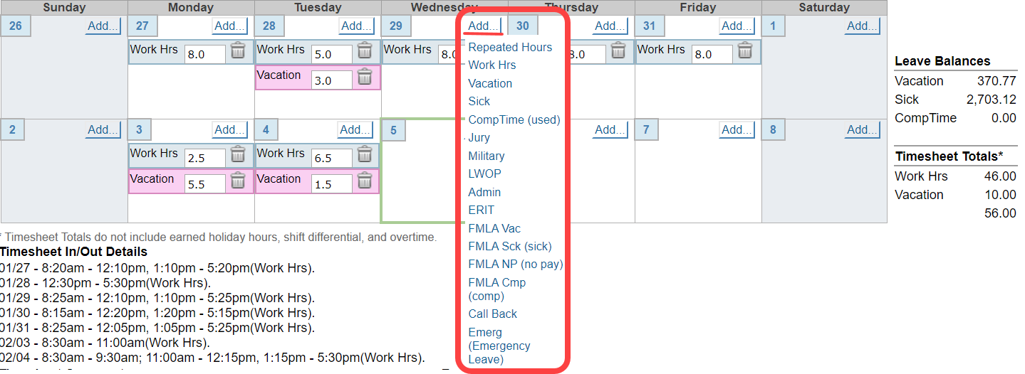

**Type of Hours:**

|  |  |
| --- | --- |
| **Type** | **Description** |
| Admin | To be determined by the Service Channel (paid time).  Sometimes an employee may take departmental approved administrative leave time away from the job to:   * Telecommute * Attend a seminar, conference, or class |
| Call Back | Use to report call back hours after your scheduled work shift |
| Comp Time (used) | Use this entry to record comp time taken |
| Emerg (Emergency Leave) | To be determined by the Service Channel (paid time) |
| ERIT | Use this entry to record time taken while on ERIT (Employee Reduction In Time) |
| FMLA Cmp (comp) | Comp Time (used) for FMLA leave (used hours from employees comp blank in UCPath) |
| FMLA NP (no pay) | Use to report FMLA time without pay |
| FMLA Sck (Sick) | Use to report FMLA sick leave (with pay) |
| FMLA Vac | Use to report FMLA vacation time (with pay) |
| Jury | Use this entry to record time off for jury duty |
| LWOP | Use this entry to record Leave Without Pay time off. Do not use this entry to record FMLA LWOP |
| Military | Use this entry to record military time off for duty |
| Repeated Hours | Use this entry to repeat hours across a range of dates. If an employee works the same shift every day and would like to report the same hours across a selected date range, the Repeated Hours is used as a copy function that allows an employee to record repeated time. It can be used to report work hours (biweekly employees only) and non‐productive time off. For example, when an employee wishes to report two consecutive weeks (80 hours) of vacation used in the pay period. |
| Sick | Use this entry to record sick time taken |
| Vacation | Use this entry to record vacation time taken |
| Work Hrs | Use this entry to record actual time worked |
|  |  |